

|  |  |  |  |  |  |
| --- | --- | --- | --- | --- | --- |
| Programme | : | **B.Tech** | Semester | : | **Winter 19 - 20** |
| Course | : | **Database Management Systems** | Code | : | **CSE2004** |
| Faculty | : | **Dr.Bhuvaneswari A&Dr.Ayesha Sheik** | Slot | : | **L27 + L28** |

Name**: Wilson Vidyut Doloy**

Registration No.**: 19BCE1603**

Ex. No. 6

17.01.2020

**SQL Correlated queries & views**

Consider the schema for **Movie Database**:

**ACTOR** (Act_id, Act_Name, Act_Gender)

**DIRECTOR** (Dir_id, Dir_Name, Dir_Phone)

**MOVIES** (Mov_id, Mov_Title, Mov_Year, Mov_Lang, Dir_id)

**MOVIE_CAST** (Act_id, Mov_id, Role)

**RATING** (Mov_id, Rev_Stars)

Write SQL queries for the following

1 List the titles of all movies directed by ‘Hitchcock’.

2. Find the movie names where one or more actors acted in two or more movies.

3. List all actors who acted in a movie before 2000 and also in a movie after 2015 (use JOIN operation).

4. Find the title of movies and number of stars for each movie that has at least one rating and find the highest number of stars that movie received. Sort the result by movie title.

5. Update rating of all movies directed by ‘Steven Spielberg’ to rating value 5.

6. Create view“MovieDetails”to show the movie id, name, Movie language and its rating star released between Year 2015 to 2019.

7. Update the view “MovieDetails” to change movie language from “English” to “Hindi”

8. Delete rows in the view “MovieDetails” where the rating is 3.

9. Drop the view “MovieDetails”

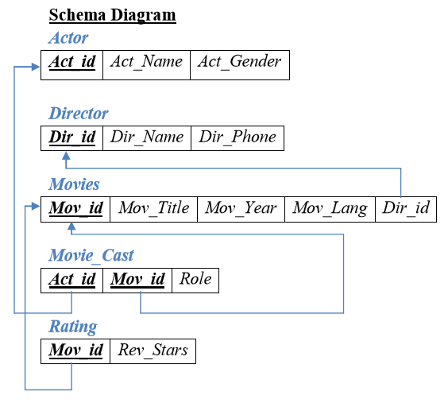

CREATE TABLE ACTOR ( ACT_ID NUMBER (3), ACT_NAME VARCHAR (20), ACT_GENDER CHAR (1), PRIMARY KEY (ACT_ID));

CREATE TABLE DIRECTOR ( DIR_ID NUMBER (3), DIR_NAME VARCHAR (20), DIR_PHONE NUMBER (10), PRIMARY KEY (DIR_ID));

CREATE TABLE MOVIES ( MOV_ID NUMBER (4), MOV_TITLE VARCHAR (25), MOV_YEAR NUMBER (4), MOV_LANG VARCHAR (12), DIR_ID NUMBER (3), PRIMARY KEY (MOV_ID), FOREIGN KEY (DIR_ID) REFERENCES DIRECTOR (DIR_ID));

CREATE TABLE MOVIE_CAST ( ACT_ID NUMBER (3), MOV_ID NUMBER (4), ROLE VARCHAR (10), PRIMARY KEY (ACT_ID, MOV_ID), FOREIGN KEY (ACT_ID) REFERENCES ACTOR (ACT_ID), FOREIGN KEY (MOV_ID) REFERENCES MOVIES (MOV_ID));

CREATE TABLE RATING ( MOV_ID NUMBER (4), REV_STARS VARCHAR (25), PRIMARY KEY (MOV_ID), FOREIGN KEY (MOV_ID) REFERENCES MOVIES (MOV_ID));

INSERT INTO ACTOR VALUES (301,'ANUSHKA','F');

INSERT INTO ACTOR VALUES (302,'PRABHAS','M');

INSERT INTO ACTOR VALUES (303,'PUNITH','M');

INSERT INTO ACTOR VALUES (304,'JERMY','M');

INSERT INTO DIRECTOR VALUES (60,'RAJAMOULI', 8751611001);

INSERT INTO DIRECTOR VALUES (61,'HITCHCOCK', 7766138911);

INSERT INTO DIRECTOR VALUES (62,'FARAN', 9986776531);

INSERT INTO DIRECTOR VALUES (63,'STEVEN SPIELBERG', 8989776530);

INSERT INTO MOVIES VALUES (1001,'BAHUBALI-2', 2017, 'TELAGU', 60);

INSERT INTO MOVIES VALUES (1002,'BAHUBALI-1', 2015, 'TELAGU', 60);

INSERT INTO MOVIES VALUES (1003,'AKASH', 2008, 'KANNADA', 61);

INSERT INTO MOVIES VALUES (1004,'WAR HORSE', 2011, 'ENGLISH', 63);

INSERT INTO MOVIE_CAST VALUES (301, 1002, 'HEROINE');

INSERT INTO MOVIE_CAST VALUES (301, 1001, 'HEROINE');

INSERT INTO MOVIE_CAST VALUES (303, 1003, 'HERO');

INSERT INTO MOVIE_CAST VALUES (303, 1002, 'GUEST');

INSERT INTO MOVIE_CAST VALUES (304, 1004, 'HERO');

INSERT INTO RATING VALUES (1001, 4);

INSERT INTO RATING VALUES (1002, 2);

INSERT INTO RATING VALUES (1003, 5);

INSERT INTO RATING VALUES (1004, 4);

1. select mov_title from movies where dir_id=(select dir_id from director where dir_name='HITCHCOCK');

MOV_TITLE

-------------------------

AKASH

1. select mov_title from movies m,movie_cast mv where m.mov_id=mv.mov_id and act_id in (select act_id from movie_cast group by act_id having count(act_id)>1)

group by mov_title having count(*)>1;

MOV_TITLE

-------------------------

BAHUBALI-1

1. select * from actor a,movies m,movie_cast mc where a.act_id=mc.act_id and m

c.mov_id=m.mov_id and (m.mov_year < 2000 or m.mov_year>2015);

ACT_ID ACT_NAME A MOV_ID MOV_TITLE

---------- -------------------- - ---------- -------------------------

MOV_YEAR MOV_LANG DIR_ID ACT_ID MOV_ID ROLE

---------- ------------ ---------- ---------- ---------- ----------

301 ANUSHKA F 1001 BAHUBALI-2

2017 ENGLISH 60 301 1001 HEROINE

1. select mov_title,max(rev_stars) from movies inner join rating using(mov_id)

group by mov_title having max(rev_stars)>0 order by mov_title;

MOV_TITLE MAX(REV_STARS)

------------------------- -------------------------

AKASH 5

BAHUBALI-1 2

BAHUBALI-2 4

WAR HORSE 4

1. update rating set rev_stars=5 where mov_id=(select mov_id from movies where

dir_id=(select dir_id from director where dir_name='STEVEN SPIELBERG'));

1 row updated.

select * from rating;

MOV_ID REV_STARS

---------- -------------------------

1001 4

1002 2

1003 5

1004 5

1. create view moviedetails as (select movies.mov_id,movies.mov_title,movies.mov_lang,rating.rev_stars from movies,rating where movies.mov_id=rating.mov_id);

View created.

select * from moviedetails;

MOV_ID MOV_TITLE MOV_LANG REV_STARS

---------- ------------------------- ------------ -------------------------

1001 BAHUBALI-2 TELAGU 4

1002 BAHUBALI-1 TELAGU 2

1003 AKASH KANNADA 5

1004 WAR HORSE ENGLISH 5

1. update moviedetails set mov_lang='ENGLISH';

4 rows updated.

select * from moviedetails;

MOV_ID MOV_TITLE MOV_LANG REV_STARS

---------- ------------------------- ------------ -------------------------

1001 BAHUBALI-2 ENGLISH 4

1002 BAHUBALI-1 ENGLISH 2

1003 AKASH ENGLISH 5

1004 WAR HORSE ENGLISH 5

1. delete from moviedetails where rev_stars=3;

0 rows deleted.

1. drop view moviedetails;

View dropped.